Frequency response of Original image:

LOW PASS FILTER:

D0=40

Frequency response of filter:

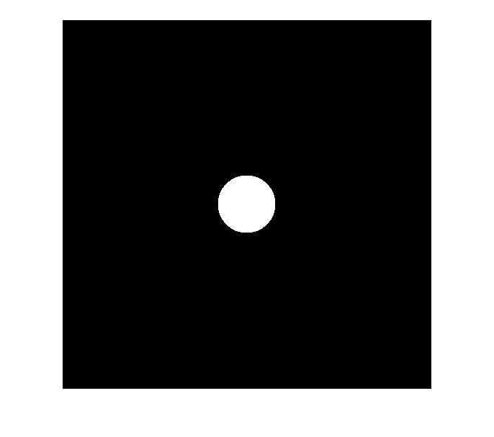

Frequency response of filtered image:

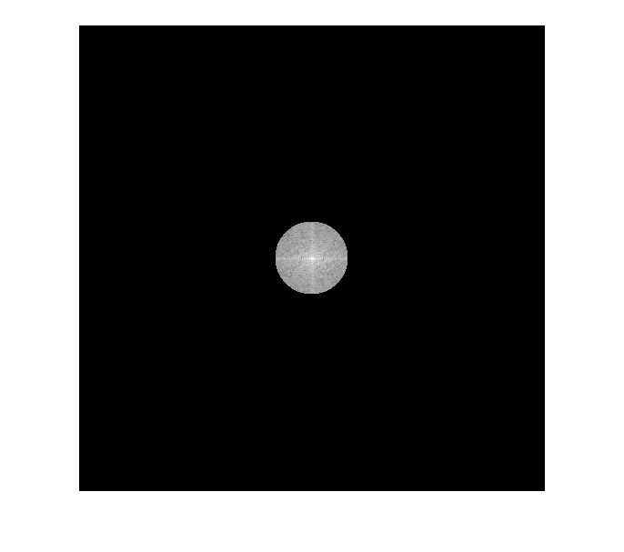

Final filtered image:

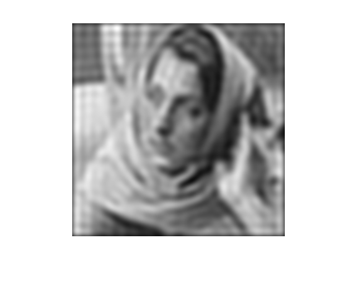

D0=80

Frequency response of filter:

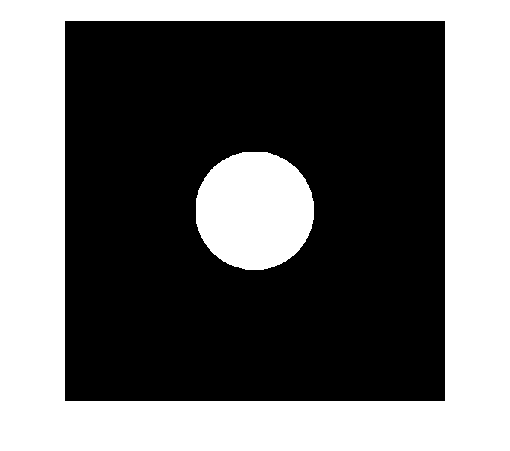

Frequency response of filtered image:

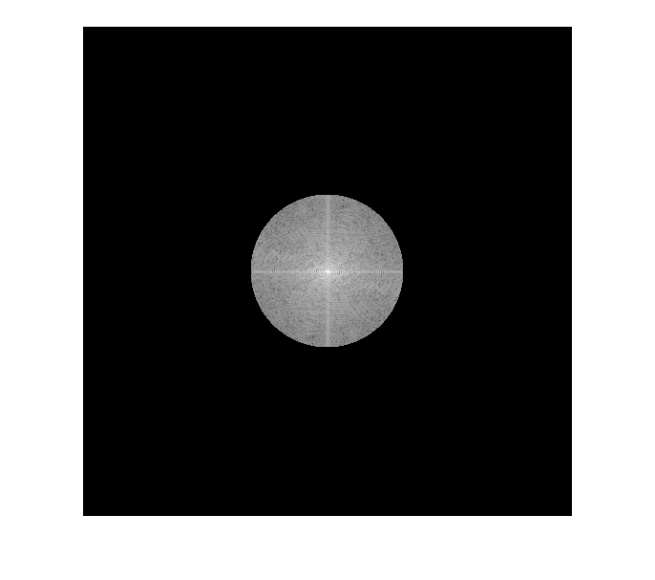

Final filtered image:

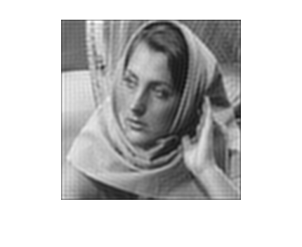

GAUSSIAN LOW PASS FILTER:

Sigma=40

Frequency response of filter:

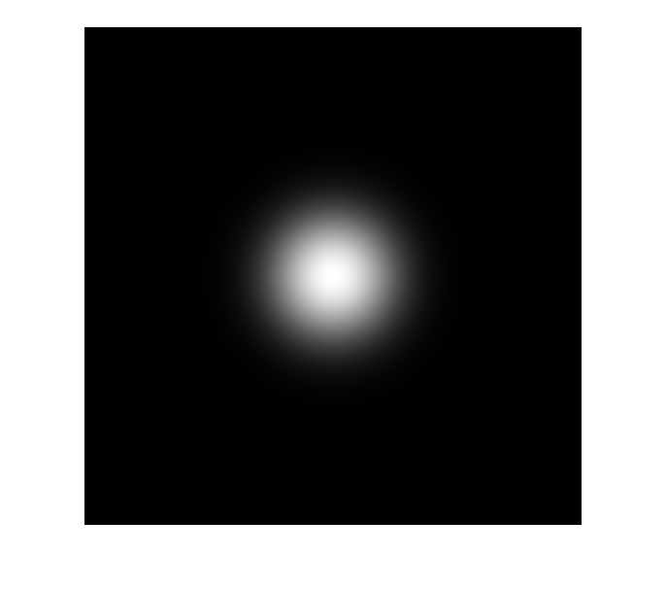

Frequency response of filtered image:

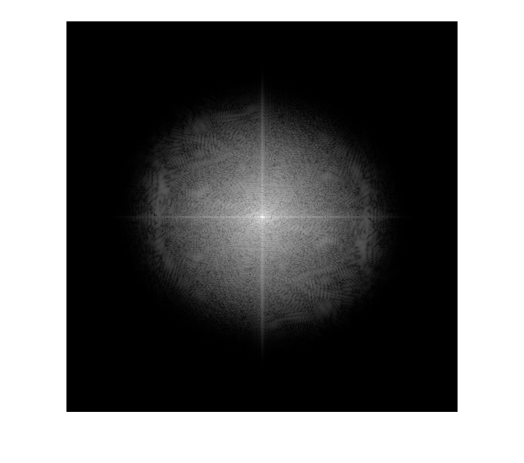

Final filtered image:

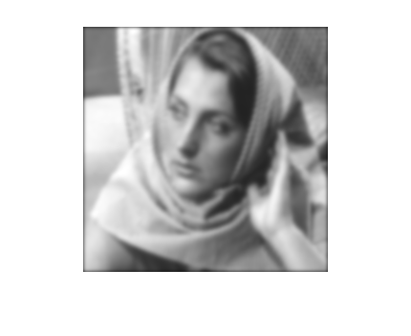

Sigma=80

Frequency response of filter:

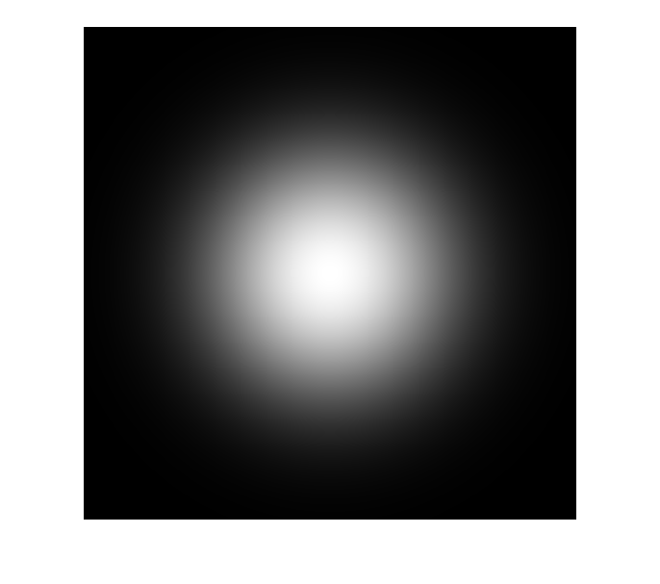

Frequency response of filtered image:

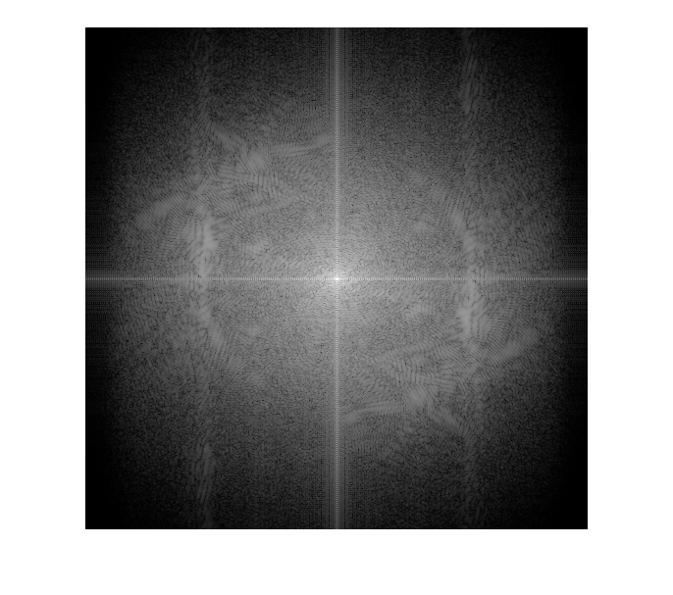

Final filtered image:

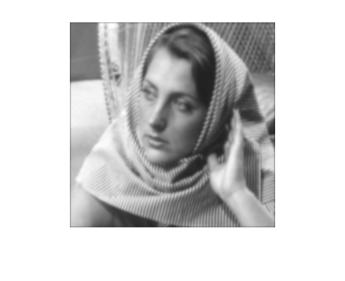

Observations:

The ringing effects can be observed more in the ideal low pass filter

Zero padding effects can be seen better in Gaussian low pass filter

Low sigma and low D0 lead to more blurring of the image

More ringing effect is seen in case of D0=40